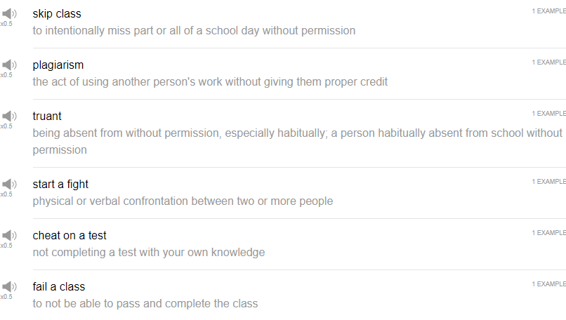

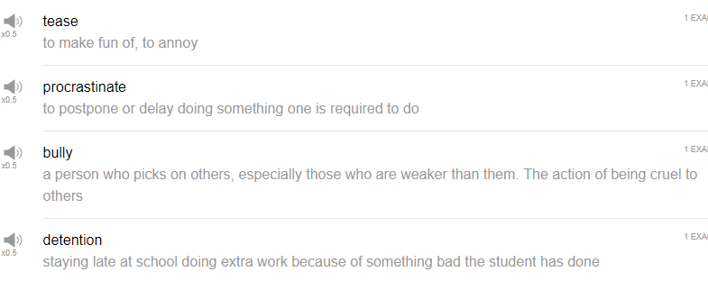

|  |
| --- |
| This is why we do what we do, to make you a better person. Hi, everybody, welcome back to Top Words. My name is Alisha, and today we're going to be talking about ten phrases for bad students. So these are probably some things that you should not do, let's get into it. |
| 1. to bully |
| This is a common problem in schools. |
| To bully someone means to be mean to another person, this might also happen in the workplace from time to time. |
| to bully someone is to put pressure on them unnecessarily, or to be violent towards them, or to hit people. It's really not a good thing to do no matter what stage of life you're in. Don't bully people, don't be mean to people. |
| In a sentence, bullying is a very common problem at school. |
| A bully is a person who bullies others, a bully is a person who is mean to other people for no reason, that's called a bully. |
| 2. to fail a class |
| Oh! The next expression is to fail a class. |
| To fail a class; if you don't do your homework, if you don't study for tests, if you don't do the projects that you're assigned, if you don't come to class, you may fail. So meaning you do not pass the class; you do not finish the class, you fail. Don't fail your classes, please don't fail your classes! Do the work that you need to do. |
| In a sentence, I failed a class last semester, I can't believe it, my parents are going to be so mad at me! I've never failed a class. |
| 3. to procrastinate |
| To procrastinate, yes! I am a professional procrastinator! |
| Like bully, procrastinate can also be used as a noun as in procrastinator. A procrastinator is someone who always puts things off. |
| In a sentence, I procrastinated last week, all last week, and now I don't have time to study for my test. Ah! |
| 4. to skip class |
| To skip class, don't skip class! |
| To skip class means to not go to class. To skip, so imagine like your class is a rock, and you go, you skip. I'm not gonna do that, that's a weird thing that I just did. Okay, just, skip class just means not to go. You have class, you have the opportunity to go to class and you just don't go; you skip. |
| That's typically not a good thing to do because your teacher, in theory, is giving you important information in your class, and you should probably be there to listen, to take notes, ask questions about that information, so don't skip class. |
| In a sentence, want to skip class with me tomorrow? No, stay at school, kids! |
| I always went to class, especially in college, I was like, I'm paying for this, like, my family is paying for this. I'm not going to skip class, like, if I skip class, I'm just throwing money away. |
| 5. to tease |
| the next verb is to tease. |
| To tease could be strongly related, I feel, to the word to bully. So bullying often has the connotation, or bullying often has the nuance of maybe physical violence; to tease is to hurt someone, or to to make fun of someone with your words. So maybe someone has a questionable haircut, or someone smells bad, or maybe they don't, maybe you're just, you just want to tease people. I will say though, that teasing is very common among friends; if, you know, you want to make fun of your friend a little bit, it shows that you have a close relationship, and that's fine. Or maybe you tease your family members or your siblings. Typically it's not good to just to go around just teasing people or making fun of them. |
| Stop teasing all the students in class, Stevens, you jerk. |
| 6. plagiarism |
| Oh yeah! The next word is plagiarism. |
| Plagiarism. I like to give lectures about plagiarism, that is true. |
| Plagiarism refers to taking someone else's work, someone else's image, someone else's text, someone else's words, and using it as your own, don't do it. It is so much trouble for you and the people around you. Oh my gosh, stop! Just stop doing it! It's so stupid. I think that this happens because students procrastinate, students don't take enough time to research and to properly document their notes, and to find their own materials or to develop their own materials, and so they use someone else's data in their paper. They get caught and they get in trouble; in some cases, this can result in fines, it can result in getting suspended or expelled from school. If you're publishing an academic paper it could be revoked, you could have a degree revoked, you could be removed from your institution, you could lose your job. Oh wow! Why would you ever do this? It's just silly. |
| In a sentence, plagiarism is much more trouble than it's worth. |
| Please don't plagiarize other authors. |
| 7. to start a fight |
| To start a fight. So we talked about the word bully before, or to bully or even to tease, but if the bullying or the teasing continues, it might start a fight, a physical fight, or a verbal fight, as well. We use the same word fight both for verbal and for physical arguments or confrontations. |
| So in a sentence, Timmy was bullying Billy at school, and it started a fight. |
| 8. truant |
| Truant is a noun; it's used for people who do not do the things that they are responsible for doing. So if you skip class, or you skip school, you can be called a truant. The administration is cracking down on truancy in the school. |
| Truant can be used as an adjective which means again not doing the things that you're supposed to do. |
| Jimmy was suspended from school for being truant. |
| 9. to cheat on a test |
| Okay, the next expression is to cheat on a test. |
| To cheat on a test means either to look at someone else's test and copy their answers; it can mean to maybe have your own answers written on, I don't know, your hat, or your arm, or maybe you're using your phone during the test to check the answers, I don't know. In some way, you are not doing your own work, you're not using your own brain to complete the test, and this is called cheating on a test. |
| Why would you cheat on a test? You're trying to test your own knowledge, if you don't do something well, then the test results will show you that, and you can improve on it, like, duh! |
| My teacher caught some students who were cheating on the test last week. |
| 10. detention |
| Detention is, in school anyway, it's the place where you are sent if you are a bad student; if you bully, if you tease, if you’re late, if you are truant, if you cheat on a test, if you do... if you commit plagiarism, perhaps; if you have bad behavior at school you may be sent to detention. |
| So detention is typically held in a classroom, for example, after school. You have to stay late after school with the other bad students, and you just have to sit there, or you have to, maybe in some cases, do some studying, or you have to do some extra work. It's a punishment for being a bad student, so you don't want to go to detention. |
| I got sent to detention last week because I threw a paper airplane at my teacher. |
| So that's the end! Those are ten phrases for bad students, I hope that you never need to use these phrases, but you might need to use them to describe the people around you. Thanks very much for watching this episode of Top Words, and we'll see you again soon. Bye bye! |
| The more you know, the less you will mess up. |
| Dare to be different. We're on a basic instructs, we're in a race for allies, we've got a run, but again it's a race that we're gonna win. Yeah oh yeah! |